Program Information | [Lesson Title]  Solving Systems of Equations  Graphing |  |  |  |  |  | TEACHER NAME  Paula Mullet |  |  |  | PROGRAM NAME  Cuyahoga Community College
Program Information | [Unit Title]  Systems of Linear Equations |  |  |  |  |  | NRS EFL(s)  4 – 6 |  |  |  | TIME FRAME  60 – 120 minutes
Instruction | OBR ABE/ASE Standards – Mathematics
Instruction | Numbers (N) |  |  | Algebra (A) |  | Geometry (G) |  |  |  |  |  | Data (D)
Instruction | Numbers and Operation |  |  | Operations and Algebraic Thinking |  | Geometric Shapes and Figures |  |  |  |  |  | Measurement and Data
Instruction | The Number System |  |  | Expressions and Equations | A.4.11  A.5.6  A.6.4 | Congruence |  |  |  |  |  | Statistics and Probability
Instruction | Ratios and Proportional Relationships |  |  | Functions |  | Similarity, Right Triangles. And Trigonometry
Instruction | Number and Quantity |  |  |  |  | Geometric Measurement and Dimensions
Instruction |  |  |  |  |  | Modeling with Geometry
Instruction | Mathematical Practices (MP)
Instruction | X | Make sense of problems and persevere in solving them. (MP.1) |  |  |  |  |  |  | Use appropriate tools strategically. (MP.5)
Instruction | X | Reason abstractly and quantitatively. (MP.2) |  |  |  |  |  | X | Attend to precision. (MP.6)
Instruction |  | Construct viable arguments and critique the reasoning of others. (MP.3) |  |  |  |  |  |  | Look for and make use of structure. (MP.7)
Instruction | X | Model with mathematics. (MP.4) |  |  |  |  |  |  | Look for and express regularity in repeated reasoning. (MP.8)
 | LEARNER OUTCOME(S)  - Students will accurately solve a system of equations by graphing. |  |  |  |  |  | ASSESSMENT TOOLS/METHODS  - Systems of Equations worksheet  - Math Scavenger Hunt completed with 100% accuracy.
LEARNER PRIOR KNOWLEDGE

- Students should have the ability to solve linear equations, convert linear equations to the slope/intercept form, and graph linear equations in the slope/intercept form.
- They will have completed earlier lessons on systems of equations, such as Solving Systems of Linear Equations Introduction.
Teacher Note Be sure to classify each system as consistent or inconsistent and dependent or independent.
 | INSTRUCTIONAL ACTIVITIES  - Review how to convert a linear equation/function to the slope intercept form (y = mx + b). (See How to Change an Equation to the Slope-Intercept Form Resource) Review how to graph equations using the slope intercept form. (See How to Graph an Equation in Slope Intercept Form Resource)  Provide practice with these skills for the students. The samples and practice exercises found in both Resources could be used for student practice or teacher review.  A review of linear equations can be found in Lesson 6.1: Linear Equations and Lesson 6.2: Graphing Linear Equations from Common core basics: Building essential test readiness skills (Mathematics).  - Using the systems of equations found on Sample Systems of Equations Handout, graph each equation in the system on the same coordinate grid. Remind students that the graph of each equation represents solutions to that equation. Ask what do they think the points found on both graphs represent? Help students understand that the solutions to two linear equations in two variables correspond to points of intersection of their graphs, because points of intersection satisfy both equations simultaneously. Use a coordinate grid overhead or large chart paper so students may see the results. Do not pass out the handout sample sheet until after completing the samples together. Be sure to elicit help from the class while graphing the systems of equations.  Include the following questions during instruction: 1) Are the equations in slope-intercept form? 2) Where is the y intercept? 3) What is the slope of the line? 4) What are the coordinates of an additional point on the line?  Complete each example with student assistance. After each example, ask students what the solution to the system of equations is. After completing the examples, the students should recognize the three possible solutions to a system of equations: one solution (where the two graphs intersect at one point), many solutions (when the graphs of both equations are identical) or no solution (when the graphs are parallel to each other).  - Distribute the handout, Sample Systems of Equations, to the students. Ask students to review the steps to solve each system of equations, graph each system (use the coordinate grid found on the page) and answer the questions (math insights) at the end of the handout.  - Students will work independently or in pairs to graph the systems of equations found on the Systems of Equations activity. Monitor student understanding by checking student responses as they are working. Based on the needs of the students, provide additional practice from math books.  - Set up a Math Scavenger Hunt in the classroom using the directions found in the Math Scavenger Hunt Teacher Resource and Answer Sheet. The questions and answers found in the Graphing Scavenger Hunt Information Sheet (provide each student with 4 copies) will provide the questions and solutions to place on each clue card. The answers are also included for your reference.  Teacher Note Please be aware that the clue cards provided are smaller than you might want to use in your classroom. They can be enlarged for display or reproduced on large chart paper. Students might have difficulty reading the scale for these graphs as they are based on the lines at .5 intervals. |  |  |  |  |  | RESOURCES  How to Change an Equation to the Slope-Intercept Form Resource (attached)  How to Graph an Equation in Slope Intercept Form Resource (attached)  Common core basics: Building essential test readiness skills (Mathematics). (2015). Columbus, OH: McGraw-Hill Education.  Student copies of Sample Systems of Equations Handout (attached)  Sample Systems of Equations Answer Key (attached)  Graph paper and colored pencils or dry-erase grid boards and markers for student use  Overhead projector with coordinate grid overlay, overhead markers  Coordinate grid paper  Coordinate grid paper (20x20) [PDF file]. (n.d.). Retrieved from http://math.about.com/library/Worksheets/Coordinate-Grid-w.pdf  Math Scavenger Hunt Teacher Resource (attached)  Math Scavenger Hunt Clue Cards 1-8 (attached)  Student copies of Math Scavenger Hunt Answer Sheet (attached)  Math Scavenger Hunt supplies:  Paper or card stock (8 ½” by 11”)  2 colored markers  Tape  Student copies of Graphing Scavenger Hunt Information Sheet (attached)  Additional resources:  Coordinate Plane. (n.d.). Retrieved from http://themathworksheetsite.com/coordinate_plane.html  Systems of Linear Equations: Graphing. (n.d.). Retrieved from http://www.purplemath.com/modules/systlin2.htm  Mathway | Math Problem Solver. (n.d.). Retrieved from https://www.mathway.com/  Lesson 6.3 Pairs of Linear Equations  Common core basics: Building essential test readiness skills (Mathematics). (2015). Columbus, OH: McGraw-Hill Education.  Lesson 5.4 Solve Systems of Linear Equations  Common core achieve: Mastering essential test readiness skills (Mathematics). (2015). Columbus, OH: McGraw-Hill Education.
DIFFERENTIATION

- Use resources to introduce the concept as in a flipped classroom or for additional practice.
- Khan Academy Videos demonstrate plotting two simultaneous linear equations.
- Additional classroom resources and websites are also provides.
- The Scavenger Hunt allows students to move around the classroom and work with others.

Reflection | TEACHER REFLECTION/LESSON EVALUATION
Reflection | Additional Information  This is part of a series of lessons on solving systems of linear equations. To continue the study, complete Solving Systems of Equations Substitutions.

How to Change an Equation to the Slope-Intercept Form Resource

Many functions are written in the standard or general form. These equations look something like this:
ax + by = c
Where a, b, and c are real numbers, and a and b cannot both equal zero.

Equations in slope-intercept form look like this:
y = mx + b
Where m = the slope of the line, b = the y intercept

It is generally easier to graph an equation in the slope-intercept form of an equation.
It is possible to convert equation in standard form to slope intercept form.
Study the steps in the example below where a standard equation is changed to slope-intercept form.

Sample 1
2x + y = 18 Original equation
2x -2x +y = -2x + 18 Subtract 2x from both sides to get the
y value alone
y = -2x + 18 Check if in slope-intercept form

Sample 2
2x – 3y = 9 Original equation
2x – 2x -3y = -2x +9 Subtract 2x from both sides
-3y/-3 = (-2x +9)/-3 Divide both sides by -3 to eliminate the coefficient with the y.
y = (2/3)x -3 Check if in slope-intercept form

For practice, change the following equations to the slope-intercept form:

6x + y = 5
6 + 2y = 8x
2y = 6x – 2
4x – 2y = 12
9 – 3y = 3x
2y – 4x + 6 = 0
-2y = 4x + 5
3x + y = 8
An answer sheet can be found following resource
Resource Answer Sheet

6x + y = 5 y = -6x + 5

6 + 2y = 8x y = 4x - 3

2y = 6x – 2 y = 3x - 1

4x – 2y = 12 y = 2x - 6

9 – 3y = 3x y = -x + 3

2y – 4x + 6 = 0 y = 2x - 3

-2y = 4x + 5 y = -2x – 5/2

3x + y = 8 y = -3x + 8

How to Graph an Equation in Slope Intercept Form Resource

y = mx+b

In the slope intercept form of a linear equation, each letter represents a special value.
m = the slope of the equation
b = the y intercept

With these two facts, an equation in slope intercept form can be graphed.

With these facts, let’s look at some equations:

Sample 1 y = 4x + 2
Sample 2 y = -x + 6
Sample 3 y = 2x -4
Sample 4 y = 1/4x

First locate point b on the graph and mark it.
Since this is the point where the graph of the equation crosses the y-axis, the x value will be zero and the y value will be the b value in the equation (0, b).

The coordinates of the y intercept in the samples would be:
Sample 1 (0,2)
Sample 2 (0,6)
Sample 3 (0,-4)
Sample 4 (0,0)

Second, determine the slope (m) of the equation. What number is before the x in the equation? If there is not a numeral in front of the letter x, remember the number 1 is understood.

The slopes of the equations in the samples are:
Sample 1 4
Sample 2 -1
Sample 3 2
Sample 4 ¼

Slope is the ratio of the change in the y value of 2 points (y2-y1) over the change in the x value of the same two points (x2-x1). This is commonly known as the rise/run. The slopes of the samples could be written as 4/1, -1/1, 2/1 and ¼ respectively. Using these values, plot a second point for each equation.

For example 1, start at the y intercept (0, 2). From this point, use the slope of the equation to find a second point on the line. The slope of the line is 4/1, so count up four spaces (the rise) and count to the right one space (the run). Where you end up is a second point on the graph (1, 6). Repeat these steps to find a third point on the graph. Remember, the slope of the line will determine the direction of the rise and run. Going up or to the right are positive directions. Going left or down are negative directions. If the slope is negative, you must have one movement in a negative direction – not both. (Remember a negative divided by a negative is a positive.)

Note Positive slopes will start lower on the left side of the graph and end up higher on the right side of the graph. Lines with negative slopes will start higher on the left side and end up lower on the right side.

The graphs of the four sample exercise are below.

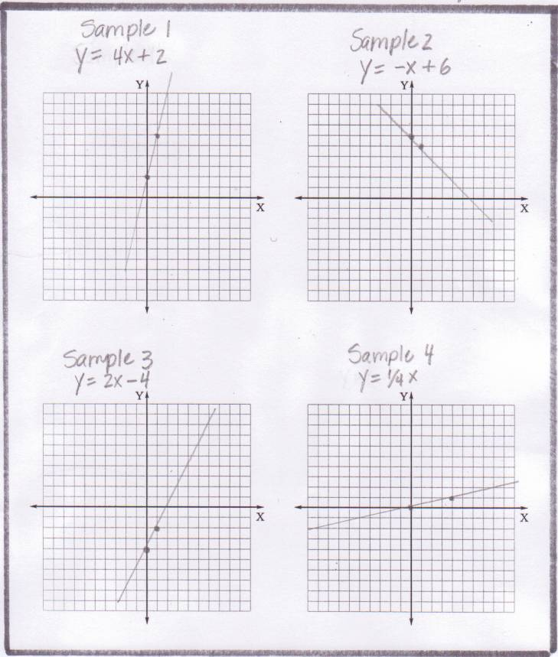

Sample Systems of Equations

Study each system of equations and the solution shown below. Graph each system in the space provided.

Sample 1  3x – 2y = 6  x + y = 2 | Change both equations to slope intercept form.  3x – 2y = 6  -2y = -3x + 6  y = (3/2)x - 3  x + y = 2  y = -x + 2 | 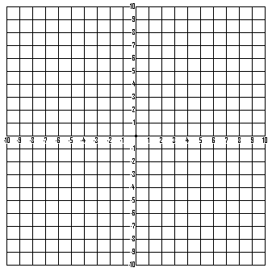
Sample 2  2x – y = 1  4x – 2y = 2 | Change both equations to slope intercept form.  2x – y = 1  -y = -2x + 1  y = 2x – 1  4x – 2y = 2  -2y = -4x + 2  y = 2x - 1
Sample 3  2x - y = -1  2x - y = 3 | Note Students should use inspection to recognize that 2x - y cannot equal both -1 and 3 simultaneously and therefore have no solution. To demonstrate this fact by graphing, change both equations to slope intercept form.  2x - y = -1 -y = -2x -1  y = 2x + 1  2x - y = 3  -y = -2x + 3  y = 2x – 3

Sample Systems of Equations Handout
Math Insights

- What is the solution to Sample 1? (Give the coordinates of the solution.)

- What is the solution to the system in sample 2?

- Can two equations that appear different (Sample 2) actually be identical?
□ Yes
□ No

- If two equations have the same slope (Sample 3), what is true about their solution?

- How many different types of solutions are there for a system of equations?

- Which systems are consistent?

Which systems are inconsistent?

Which systems are dependent?

Which systems are independent?

Sample Systems of Equations Handout
Sample Systems of Equations
ANSWER KEY

Sample 1  3x – 2y = 6  x + y = 2  Intersection (2,0) | 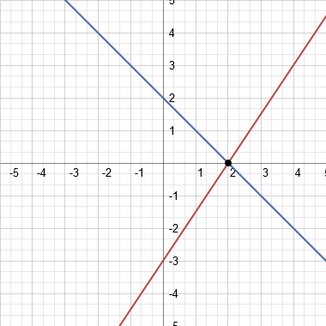

Sample 2  2x – y = 1  4x – 2y = 2  Many Solutions | 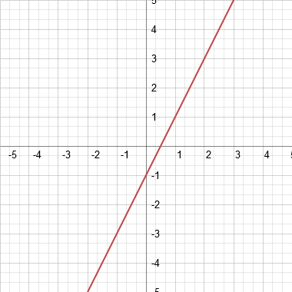

Sample 3  y = 2x + 1  y = 2x – 3  No Points of Intersection | 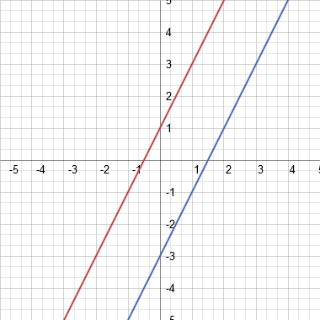

Math Insights

- What is the solution to Sample 1? (Give the coordinates of the solution.)
(2,0) x = 2, y = 0

- What is the solution to the system in sample 2?
All solutions

- Can two equations that appear different (Sample 2) actually be identical?
Yes - One of the equations can be simplified

- If two equations have the same slope (Sample 3), what is true about their solution?
There is no solution Note: y-intercept is different in each equation

- How many different types of solutions are there for a system of equations?
one solution, consistent, independent
many solutions, consistent, dependent
no solutions, inconsistent

- Which systems are consistent? Sample 1, 2
Which systems are inconsistent? Sample 3
Which systems are dependent? Sample 2
Which systems are independent? Sample 1

Systems of Equations Activity
Graph the following systems of equations to find the solution to each system.

y = -4x + 5 y = -3x + 7
y = 3x – 9 y = 2x - 3
x + 3y = 6  x – 3y = 6 | y = x + 6  y = -2x
y = 4x – 3  y = -2x + 9 | 3x – 2y = 4  y = -2x + 5
3x – 2y = 6  x – y = 2 | x + y = 4  2x + 2y = 10

Systems of Equations Activity ANSWER KEY

y = -4x + 5  y = 3x – 9  Intersection (2,-3)  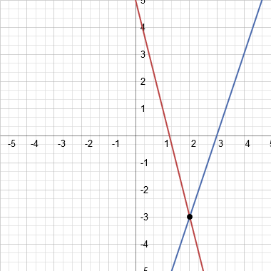 | y = -3x + 7  y = 2x – 3  Intersection (2,1)  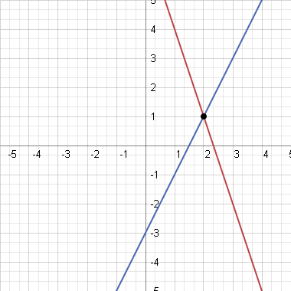
x + 3y = 6  x – 3y = 6  Intersection (6,0)  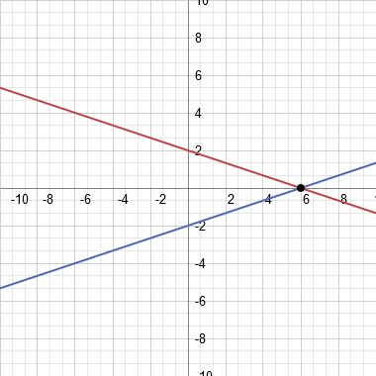  Note: Change in scale of graph | y = x + 6  y = -2x  Intersection (-2,4)  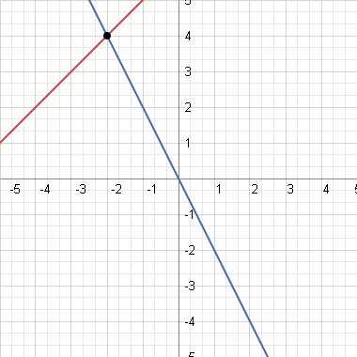
y = 4x – 3  y = -2x + 9  Intersection (2,5)  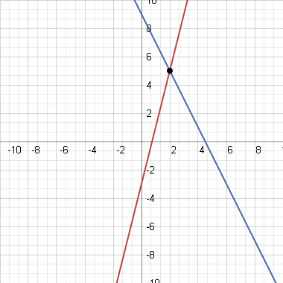  Note: Change in scale of graph | 3x – 2y = 4  y = -2x + 5  Intersection (2,1)  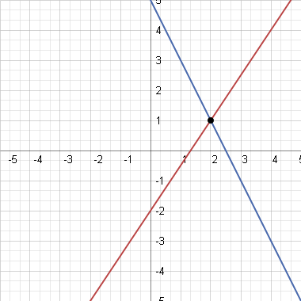
3x – 2y = 6  x – y = 2  Intersection (2,0)  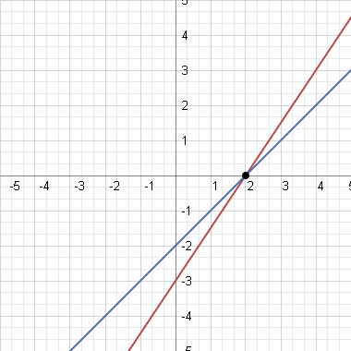 | x + y = 4  2x + 2y = 10  No Solution  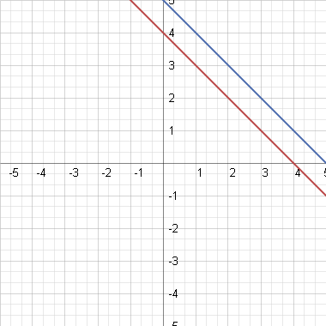

Math Scavenger Hunt Teacher Resource

Supplies
Paper or card stock (8 ½” by 11”)
2 colored markers
Tape

A math scavenger hunt is a fun way to assess the math skills of your students. Most any math topic can be evaluated with this activity, and the students will stay active as they move around the room solving problems and searching for the answers. Students can work in groups or alone as they complete the activity.

To set up a scavenger hunt select 6-8 problems with answers. Before you make the scavenger hunt clue cards, do some planning to make sure each problem and its answer will be on different cards. This has already been done for you in the series of lessons on systems of equations. When you have decided on the problem and answer to place on each card, write a problem at the top (portrait orientation) of the clue card and a solution at the bottom of the card. Write all the answers in one color of marker, and use the second color for the problems. Tape these sheets around the room.

Math Clue Card Example

2 x 4

10

Now it is time for the students to complete the Math Scavenger Hunt. Give each student a Scavenger Hunt Answer Sheet (see below). Students can start their hunt at any location in the room. This way the class will be spread out around the classroom. At their first stop, the students will write the problem on their answer sheet and solve it. Remember the problem will be at the top of the sheet. There is space on the answer sheet for the students to show their work. Once they have solved this problem they will find the Scavenger Hunt Clue Card with their answer. The problem at the top of this clue card will be the students’ next problem to solve. If the students don’t find their answer when they look around the room, the students know to redo their work. Students continue with this process until all the problems have been completed, and they return to the card which contains their first problem.

The answers can be corrected quickly because the answers will be in a specific order. Remember each student will start the Scavenger Hunt in a different place in the answer sequence.
Math Scavenger Hunt Student Answer Sheet

Answer/Intersection _________

Answer/Intersection _________

Graphing Scavenger Hunt Clue Card #1
y = -x + 5
y = 1/3 x + 1

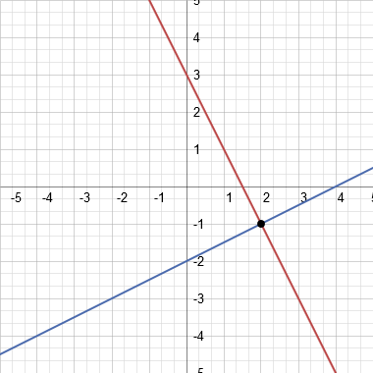

Graphing Scavenger Hunt Clue Card #2
3x + y = 3
X – 4y = -12

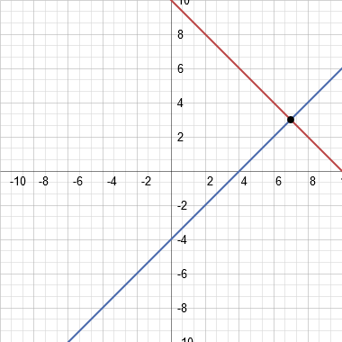

Note: Change in scale of graph

Graphing Scavenger Hunt Clue Card #3
Y = -x + 6
Y = -x + 3

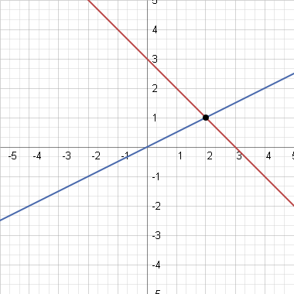

Graphing Scavenger Hunt Clue Card #4
x + y = 10
x – y = 4

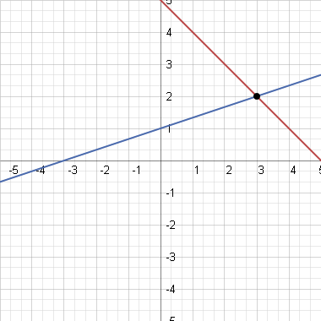

Graphing Scavenger Hunt Clue Card #5
x + y = 4
y –x = 2

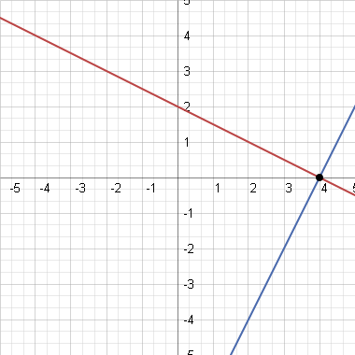

Graphing Scavenger Hunt Clue Card #6
Y = -x +3
Y = ½ x

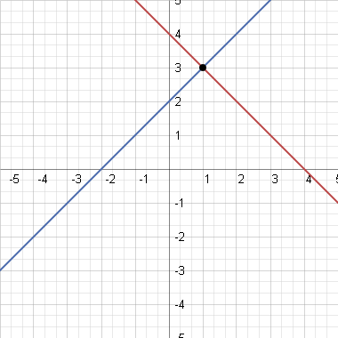

Graphing Scavenger Hunt Clue Card #7
x + 2y = 4
2x – y = 8

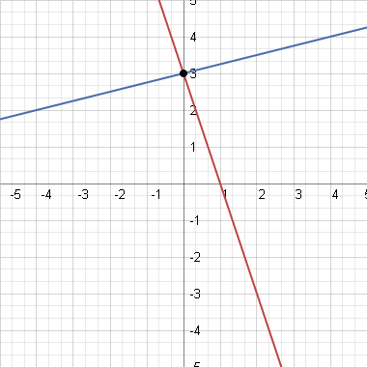

Graphing Scavenger Hunt Clue Card #8
y = -2x + 3
y = ½ x - 2

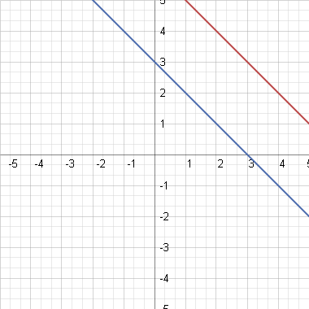

Graphing Scavenger Hunt Clue Cards
TEACHER ANSWER KEY

Sequence of answers/intersections on the answer sheet:

(3, 2)

(7, 3)

(0, 3)

(4, 0)

(1, 3)

(2, 1)

No Intersection-Parallel lines

